NHS Fife Immunisation Service  Meningococcal ACWY / MMR Vaccine Advice for  St Andrews University Students September 2020 | 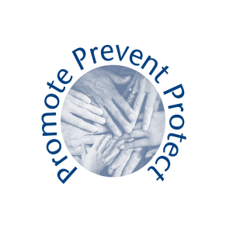

NHS Fife Immunisation service provides vaccinations to the population of Fife.
You are about to embark on your university studies and we would encourage you to find out if you have missed having Meningococcal ACWY OR one or both Measles Mumps and Rubella vaccinations.
If you are unsure whether or not you have not received these we would encourage you to contact your GP Practice in the first instance.
NHS Fife Immunisation service will be working alongside St Andrews University to provide vaccination clinics to those eligible students who are under the age of 25 years.

Why are these important

Meningococcal ACWY
What is MenACWY? MenACWY (meningococcal group A, C, W and Y bacteria) can cause meningitis (an infection of the lining of the brain) and septicaemia (blood poisoning). Meningitis and septicaemia are both very serious – they can cause permanent disability and death and the symptoms can come on quickly – so you must get treatment straight away. After babies, young people are particularly vulnerable to meningococcal infection.
Meningitis and septicaemia are caused by several groups of meningococcal bacteria – the most common groups are A, B, C, W and Y.

Measles Mumps and Rubella (MMR)
It is important that all young people have had two doses of the MMR vaccine to help protect them against measles, mumps and rubella. If you haven’t had both doses yet, you may still be at risk. If you haven’t previously had two doses of the MMR vaccine, you may have another opportunity to get it. If this is your first dose, a second dose will increase protection and should be given a month after the first dose.
Where can you access further Information
www.nhsinform.scot/immunisations
fife.immunisationqueries@nhs.scot
NHS Fife Immunisation Service: Telephone 01383 565456

